ANNUAL ACTIVITY REPORT
2020-2021

Village: Rui, Hotel Le- Meridien Road, Wardha Road,
Nagpur

From the Desk of the Director

GHIMR- creating enduring value for MBA
It gives me immense pleasure to present the Annual Activity Report of GHIMR for the academic session 2014-15.
The past year was eventful and challenging for the faculties. The increased activities / events coupled with dip in students’ attendance and course completion reflected stress on faculties. However, with great enthusiasm and inspiration, we are now poised to restore and march towards another new academic session.
During the academic session 2014-15, we have been through a journey of redefining our strategies.
Interms of accoladesGHIMR is ranked as 17th in top 20 Emerging Management Institutes of India by Higher Education Review (HER), in “Beyond IIM’s B-School Survey 2015”.
As an MBA institute, deeply rooted in rural area, GHIMR is inspired by the opportunity to serve educational purpose and creating enduring value for its stakeholders.This abiding vision has spurred innovation and vitality to ensure a substantial and growing contribution to the education whilst simultaneously contributing to make managers for the future. We will continue to ideate and innovate to take this reputed institute to greater heights.
In the end, I take this opportunity to express in depth gratitude to management for being with us and providing the opportunity to remain committed to deliver more value in future
Yours Sincerely,
Curricular Activities
Two Days Online Workshop on Research Methodology
19th -20th June 2020

Green Heaven Institute of Management and Research conducted “A Two Day Online Workshop on Research Methodology”on 19th and 20th June 2020 for the students of Commerce and Management.The core objective of the workshop was to equip the research scholarswith set of skills and potentiality to undertake research very effectively inthe disciplines of social science and Business Management and also enable students to convert completed research into publishablematerial of high quality in the form of articles, journals and books.During the Two Day Workshop, the resource person,Dr.AshishLinge,Assistant Professor,Dept. of Business Management, CP and Berar College,provided practical guidelines to studentsthrough all the stages of research.108 students from different colleges of Nagpur as well adjacent areas attended the workshop.
Day I
On the first day of the workshop,the resource person dealt with First Steps in Research where he provided guidelines for selecting the Research Topic, Setting of Research Objectives,Hypothesis formulation and tips for writing Research Synopsis.For the benefit of the students the session was taken in a very simple language and ways of framing the title was explained elaborately. Based on the title and problem definition, ways of setting the objectives was also taken up in a detailed manner. Concept of Hypothesis, its importance and method of formulation was taught by Dr.Linge.Simple examples of project titles and were taken up and various stages of Project writing taught in very simple and effective manner.Several queries from students were taken up at the end of the session. Citing examples from HR, Finance as well as Marketing the queries of the students were taken up one by one and clarified.

Day II
With the overwhelming response of students on day I and presence of students at right time for the second day,the resource person was also happy and enthusiastic to take up‘The art and science of conducting research’. Selecting the suitable research design is one the most important step in research and report writing. Hence, the resource person took up examples from different disciplines and explained the type of research to be carried out in each case.Questionnaire plays an important role in research hence proper and correct method of designing questionnaire was explained by Dr. Ashish Linge. Taking up various titles, sir put forth the method of title designing, setting objectives, hypothesis formulation,designing research and questionnaire and finally the research report.Students raised a number of questions which were clarified by the expert. The program ended by proposing vote of thanks by Dr.MubinaSaifee. The program was coordinated by Dr.Rajani Kumar under the guidance of the Director,Dr. Anil Sharma.

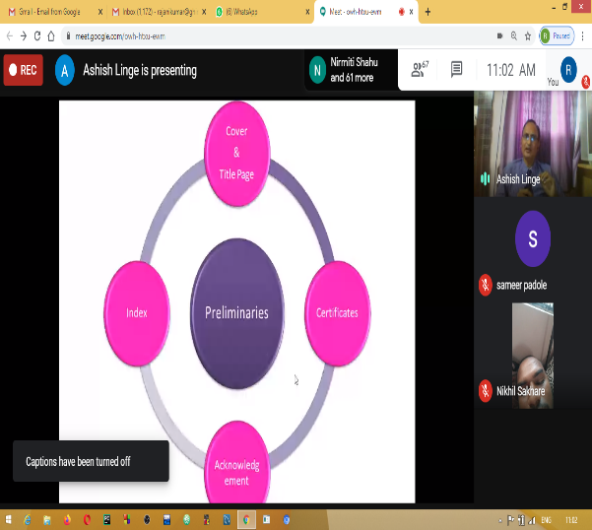
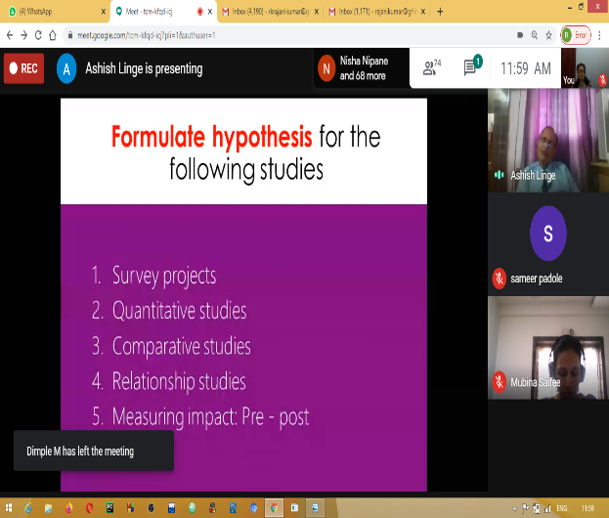

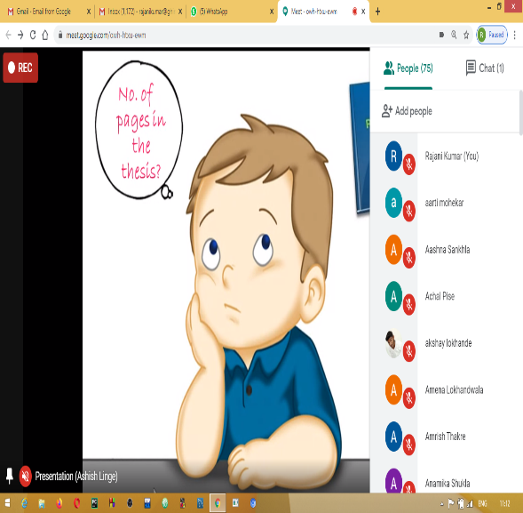
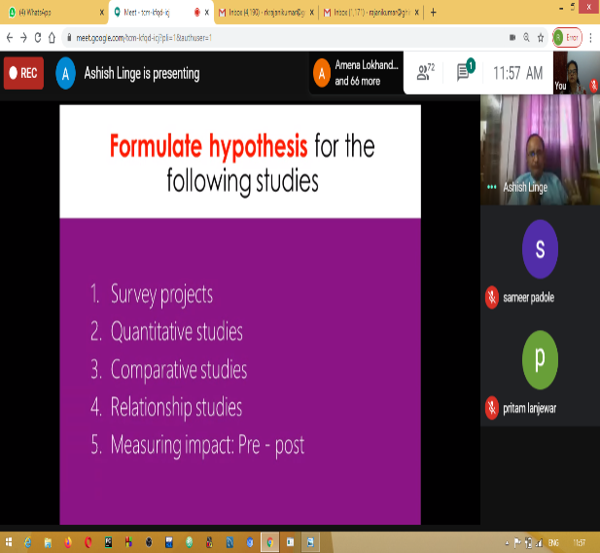

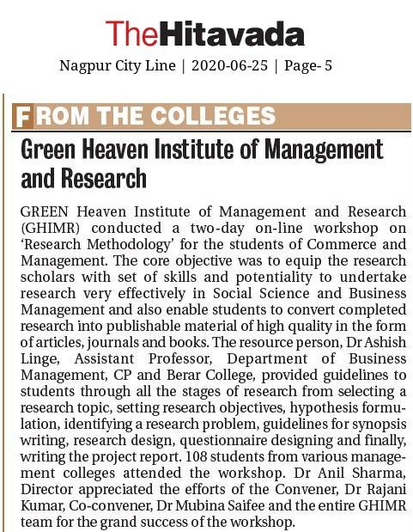

2 Day National level Faculty Development Program on “E-Learning and ICT Tools for Effective Teaching and Learning”
29th and 30th June 2020

Covid-19 has resulted in all the Educational Institutions shut all across the world, as a result education has changed dramatically, giving rise to e-learning or online teaching posing various challenges and opportunities to the Teaching Fraternity. Considering this A 2 Day National level Faculty Development Program on “E-Learning and ICT Tools for Effective Teaching and Learning”. was organised by Green Heaven Institute of Management and Research, Sponsored by Bajaj Steel Industries Ltd., NagpurThe Resource persons for the FDP were Dr.Dr. Raaju G. Sunder, Professor, University of Petroleum and Energy Studies, Dehradun, Uttarakhand and Dr. Meheraz Haque Assistant Professor, Amity School of Communication, Amity University Madhya Pradesh,Gwalior. FDP got an overwhelming response from all across the country, with 200+ Participants, attended session on both the days.
Day-I

On the first day the resource person was Dr. Raaju G. Sunder, Professor, University of Petroleum and Energy Studies, Dehradun, Uttarakhand. He elaborated the topic Impactful Online Teaching and Student Engagement Techniques”. In his 2 hours of session, he took the participants to various Open Education Resources, which can help them making their online teaching more effective. He also shown various websites, which can help the participants to get various multimedia objects to be included in the PPTs and other modes of e-learning to make them more interesting. He also demonstrated various tools which are available free on web can be used by teaching fraternity to engage students during online learning.

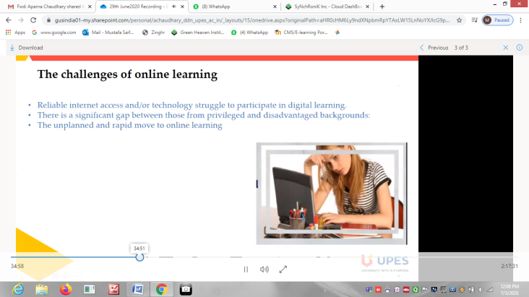
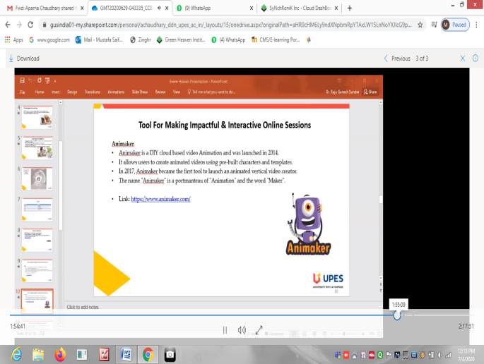
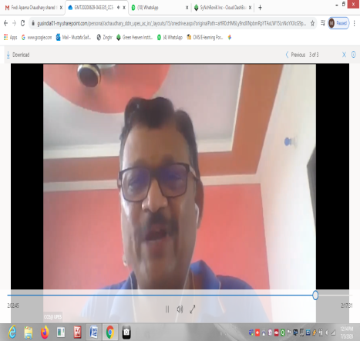
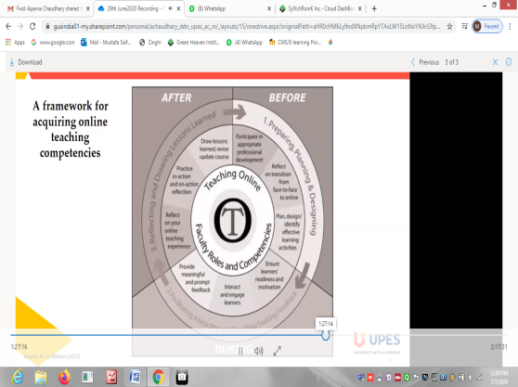

Day-II

Topic dealt on second day was “How to make E-Learning more Intimate, Engaging and Interactive”, resource person Dr. Meheraz Haque elucidated various challenges faced during online teaching and possible solutions to it She also took participants to Creative Commons and Copyright issues while using contents from the internet. She very well helped the participants by providing various techniques which help the Faculty members to give an Human Element to the
online class. In the last part of her session she guided the participants on developing their own e-content which can be uploaded on various MHRD projects like SWAYAM, E-PG Pathshala etc

Dr. Anil Sharma, applauded the efforts of Convener, Dr. Mubina Saifee, Co-Convener, Dr. Rajani Kumar, Faculty Co-ordinators, Prof. Minakshi Shendre and Prof. Sameer Padole and the entire team of GHIMR for the grand success of the program
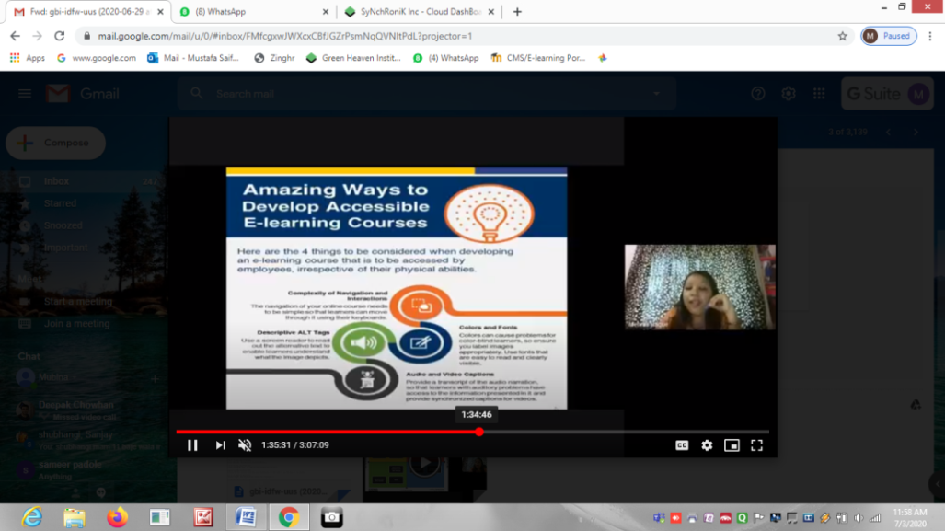

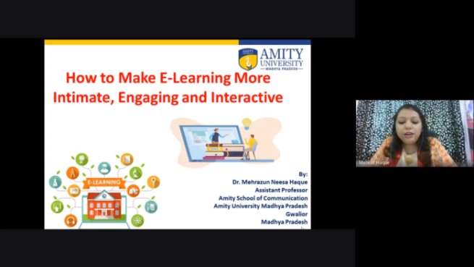

Times Of India, Nagpur Times- Date: 10/07/2020

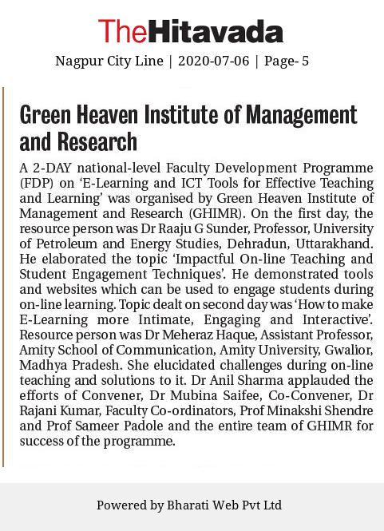
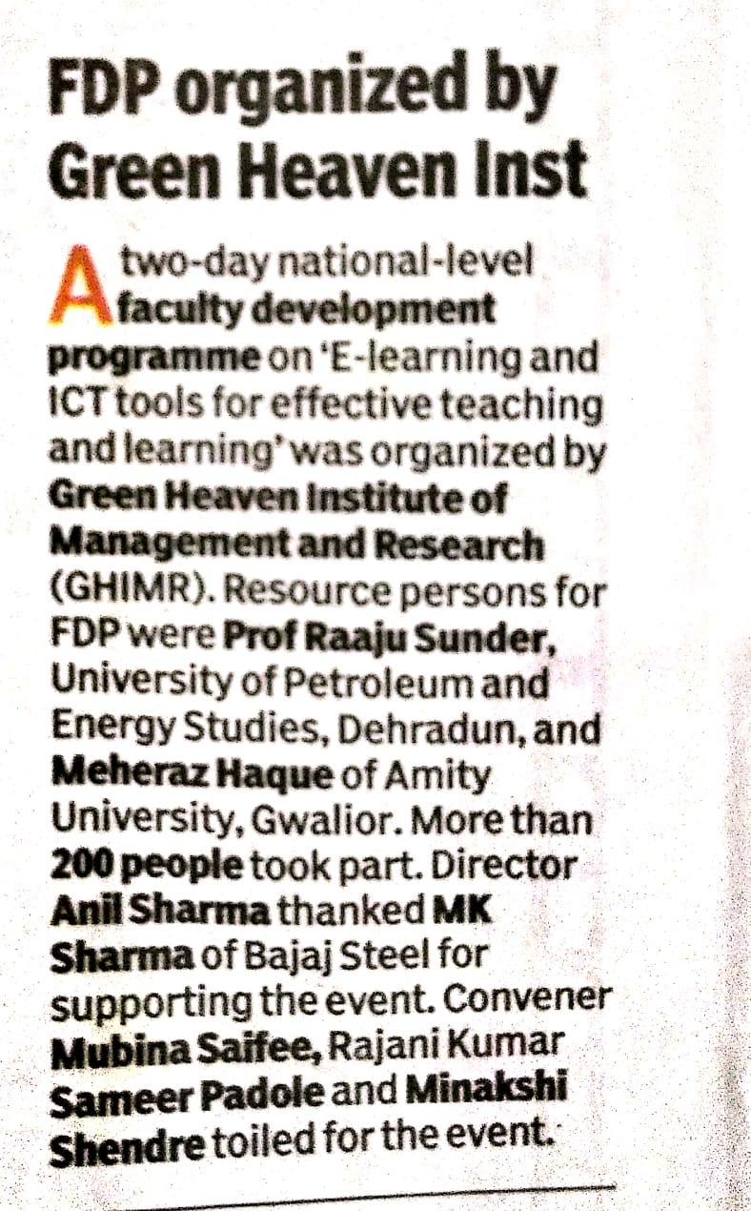

“ANKUR 20-21”- The Induction Program at Green Heaven Institute of Management and Research
8-13th Feb 2021
“Ankur- 20-21”- One Week Online Induction Programme of Green Heaven Institute of Management and Research, Nagpur was recently conducted for its 12th Batch of MBA students. The Director,Dr. Anil Sharma welcomed and congratulated the students for making the right choice and taking admission in Green Heaven Institute of Management and Research. Senior Professor,,Dr. Kailash Kadu advised students to regularly participate in college activities and utilize their time judiciously to develop their knowledge and skills.
With an objective of making the students acquainted with the college environment as well as introduce students to core subjects such as Financial Management, Accounts, and Statistics, introductory sessions on various topics were conducted .The program included sessions by the Faculty Members and Guest Speakers based on Academics, Communications, Indian Ethos and Values, and non-academic activities which would be conducted in the College for the next two years. A session on “Step towards Corporate Life”was taken by Mr. Ankush Shukla,an alumni who encouraged students to develop their employability skills and be corporate ready.
Dr. Anil Sharma, Director, appreciated the effort of the institution and congratulated the team for successful conduction of the program. The program was organized by Sem III students under the guidance ofAcademic Co-ordinator, Dr.Rajani Kumar, and Faculty Members.
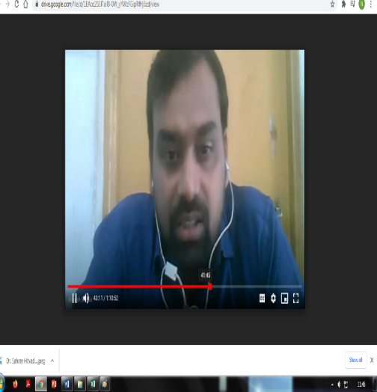
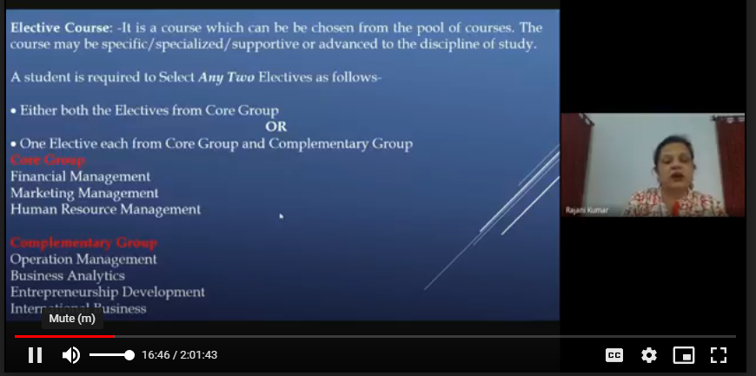
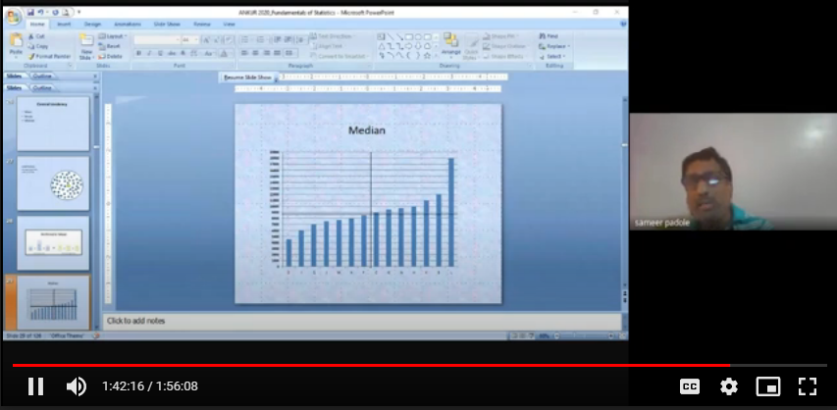
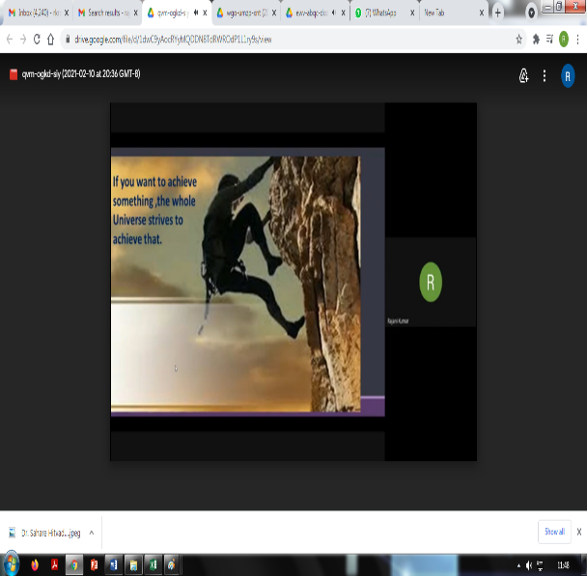

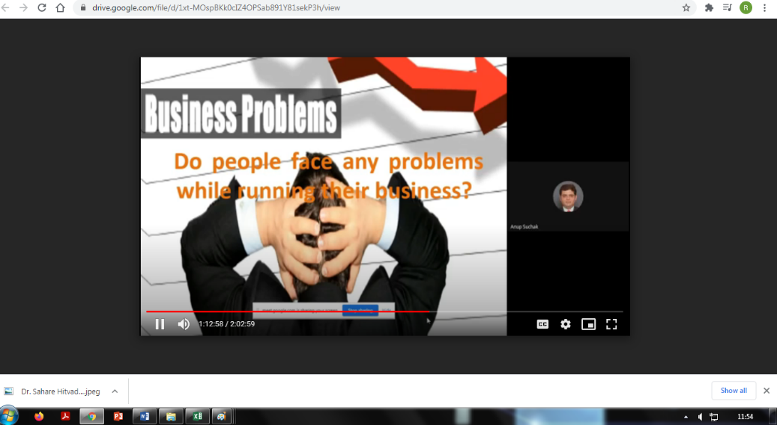

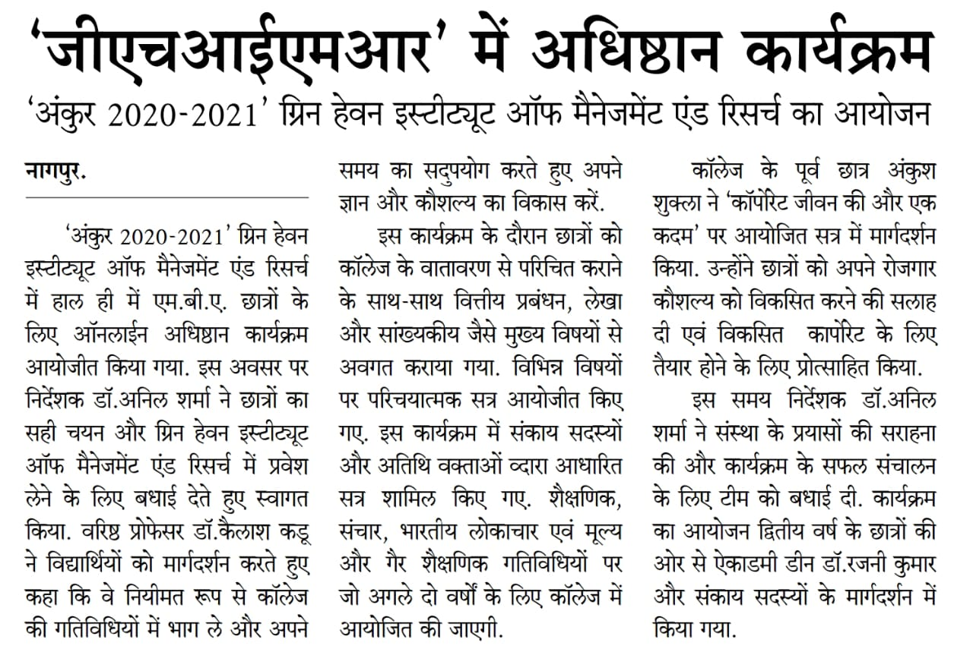

A Report on
Online Guest Lecture on Overview of Financial and Investment Management by Mr. Amol Chaporkar
November 12, 2020
The college organized an online guest lecture for its semester III students. The topic of the lecture was “overview of financial and investment management”. The lecture was delivered by Mr. Amol Chaporkar, Assistant Vice President, Corporate Lending Group, Siemens Financial Services Pvt. Ltd, Mumbai. The lecture was attended by majority students interested to make a career in finance.
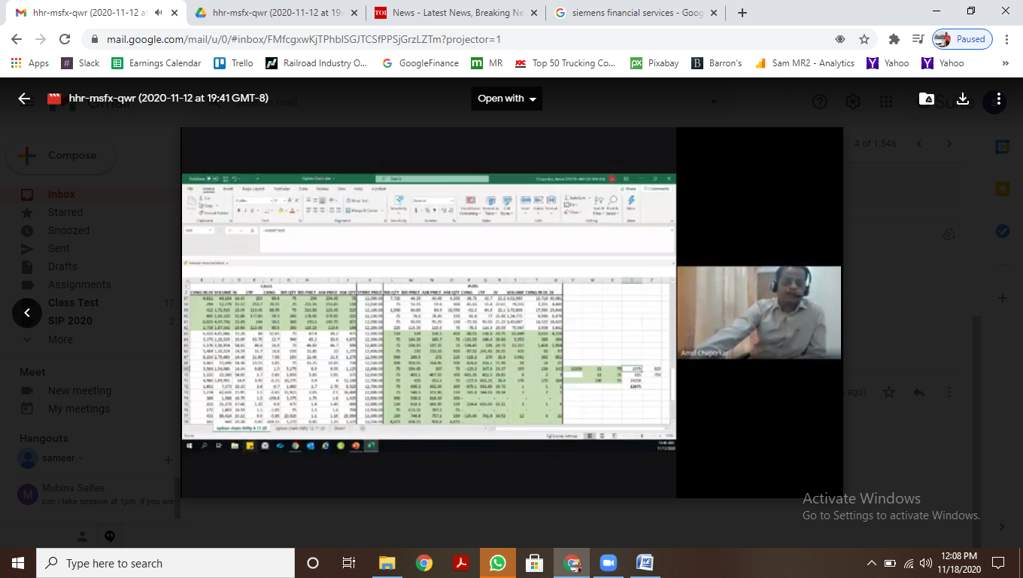

The guest faculty briefed the students on the general aspects of financial management. He also spoke in detail on the various investment avenues available to retail investors. He touched upon the trading opportunities available to retail investors and the risks associated with trading in futures & options market vis-a-vis cash market. He advised students to study the stock market for a considerable period of time before jumping into it to make fortune. He quoted examples on F&O from the website data of BSE and NSE to make the session more interactive. The online guest lecture was moderated by assistant professor Sameer Padole under the supervision of Dr. Rajani Kumar, Academic Coordinator. GHIMR’s director Dr. Anil Sharma lauded the faculty efforts for adding value to students.

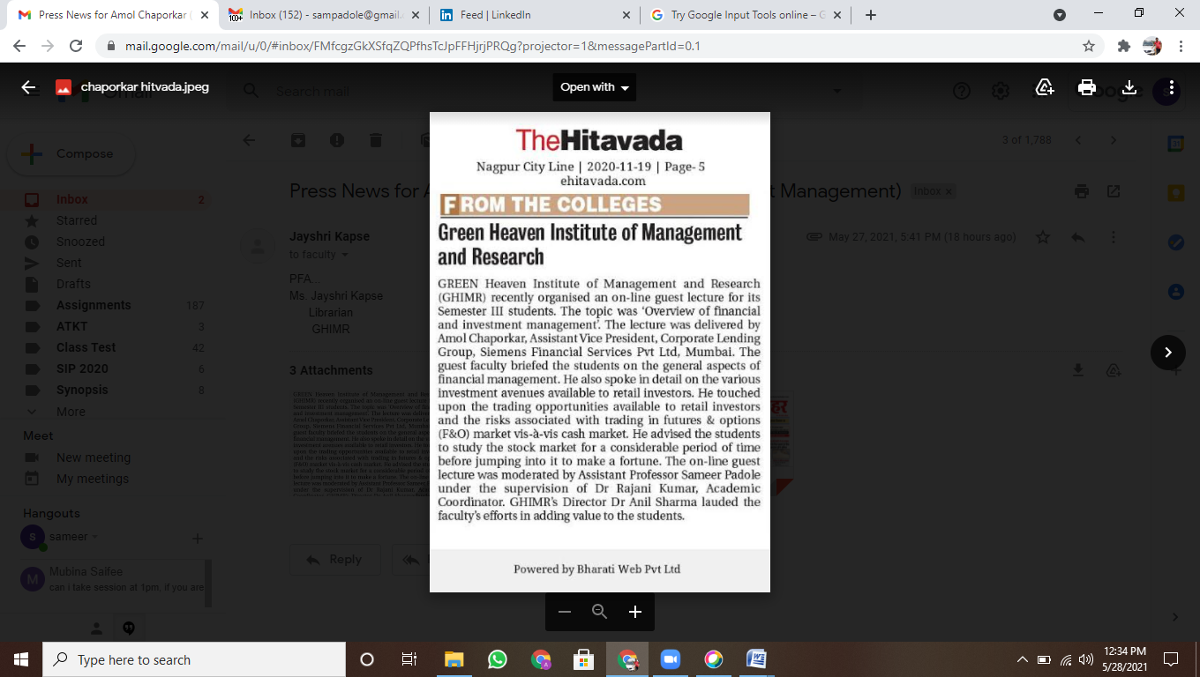
Times of India, November 24, 2020
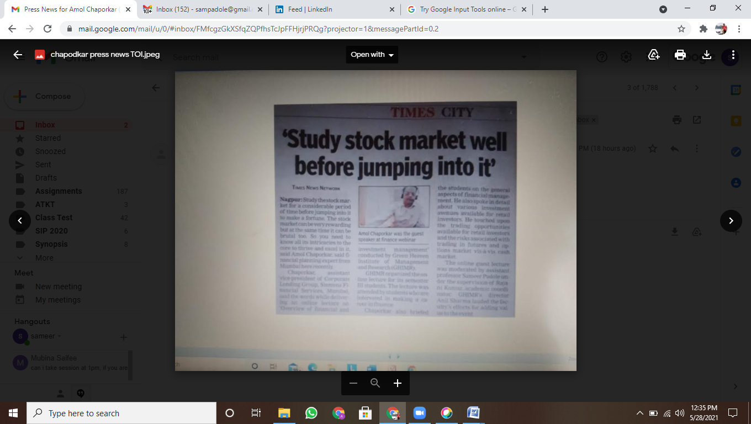

Khabaro Me Hamara Shahar, Dec 3, 2020
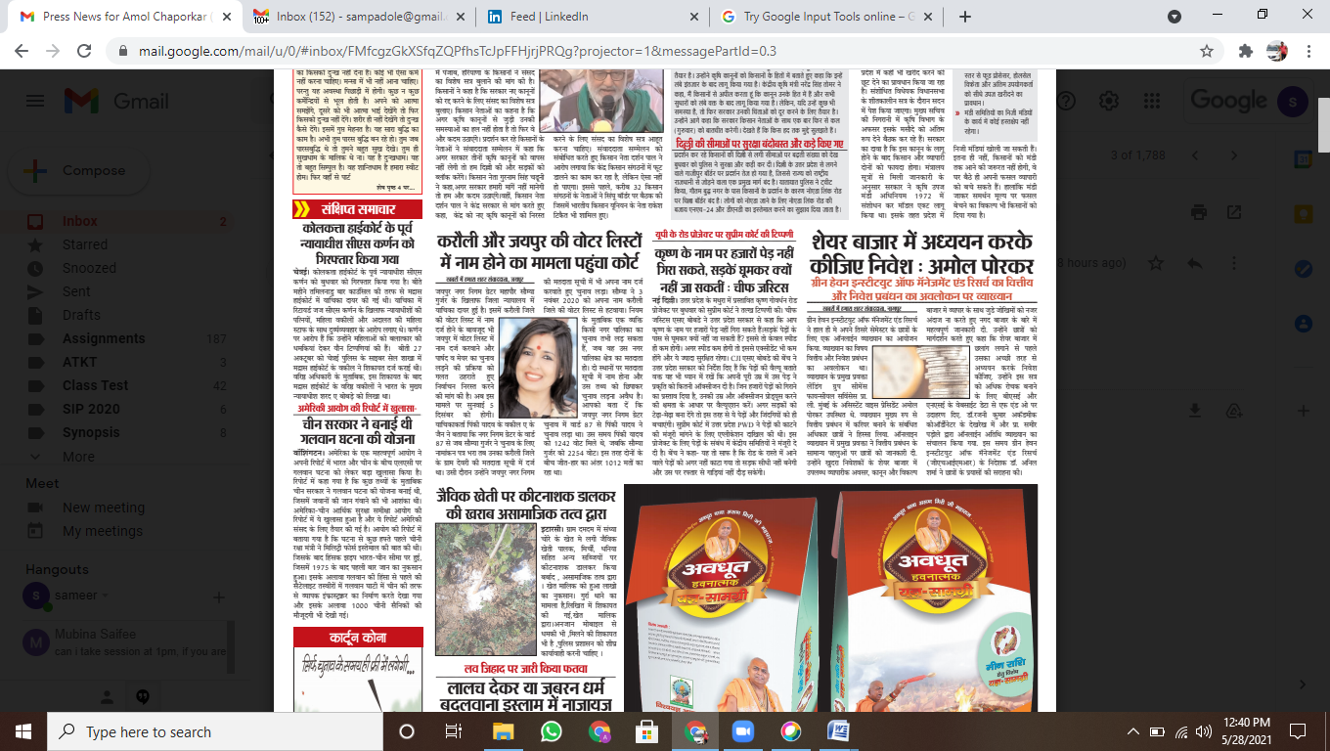

A Report on
Mrs. Sarita Bhattacharya’s Webinar
Soft Skills and Personality Development- First Step towards Corporate life

27 February, 2021
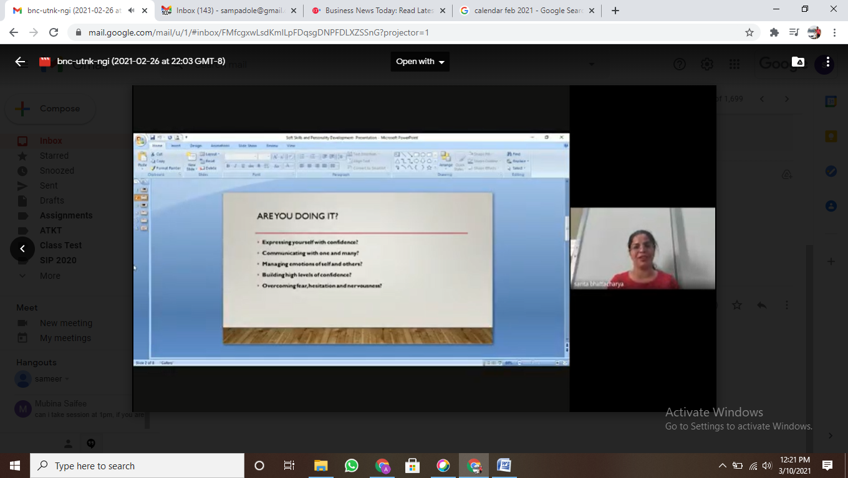
The college hosted an online webinar on Soft Skills and Personality Development- First Step towards Corporate life for the student fraternity. The key speaker on the occasion was Mrs. Sarita Bhattacharya, Branch Manager – Nagpur, IDP Education India Pvt. Ltd.

Sarita Bhattacharya started the session from her own experience in corporate life. She emphasized the importance of self-branding and clarity in communication to the audience. Mrs. Bhattacharya stressed on the vitality of three Cs in corporate life post management education, namely—Character, Confidence and Communication. The speaker urged the students to overcome their fear, hesitation and nervouseness by practising yoga, taking part in activities and managing emotions.
She outlined the importance of being well dressed and manners and etiquattes as first stepts towards corporate life. The speaker emphasized on the importance of being multi-lingual and using the power of one’s conscious and subconscious mind. Sarita Bhattacharya appeled the students to hone their domain skills, technical skills and interpersonal skills and wisely utilize their time during the two year MBA program.
Nagpur Metro Samachar. 24 March, 2021

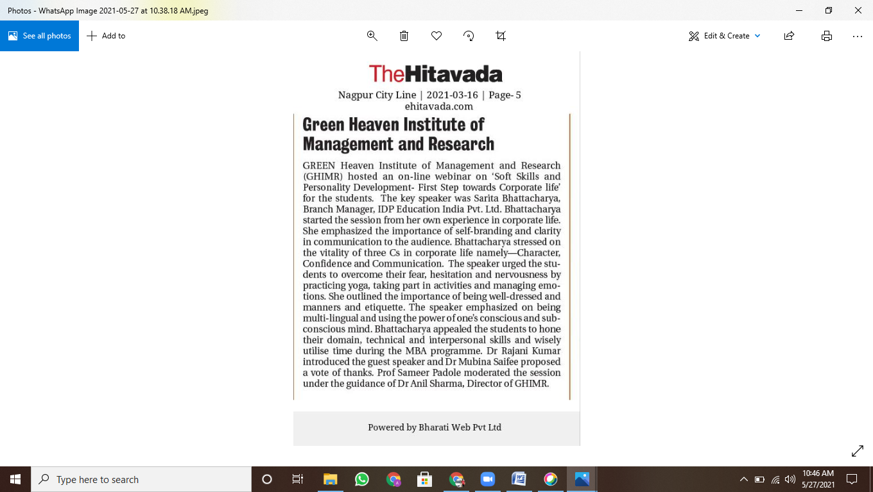
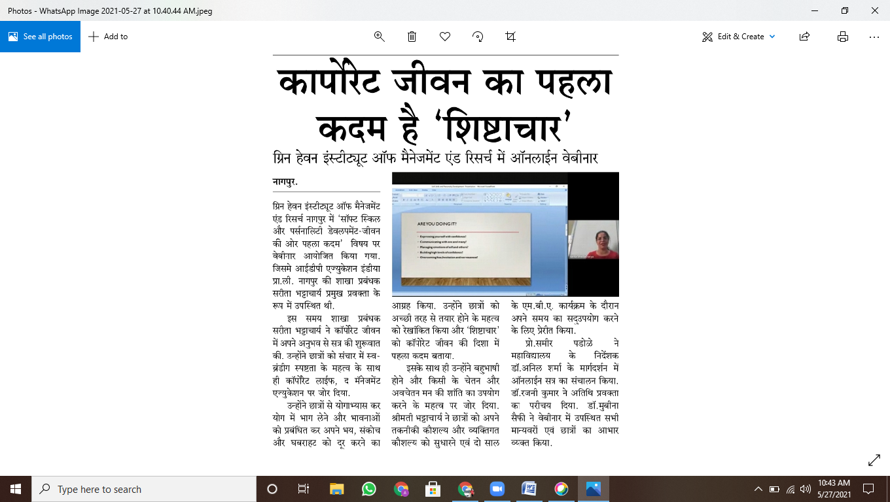

Online Workshop on “Digital Marketing and Growth Hacking”
March 6 2021
Digital Marketing is growing at a great speed, and with great speed comes great opportunity so, Green Heaven Institute of Management and Research, Nagpur has conducted Power Workshop on Digital Marketing and Growth Hacking on 6th March 2021. Resource person for this online workshopwas Mr. GovindChandak, Business Head - NSDM INDIA. The Session covered all the aspects of Digital Marketing. Students were made to understand different forms of Digital Marketing its growth and the career opportunities available in this field. Students attended the session with great zeal and asked many queries related to the topic and training required for the same. Dr. Anil Sharma, Director of GHIMR wished to have more such session to boost and increase the employability skills of the budding managers. Dr. MubinaSaifee, coordinated the guest lecture.
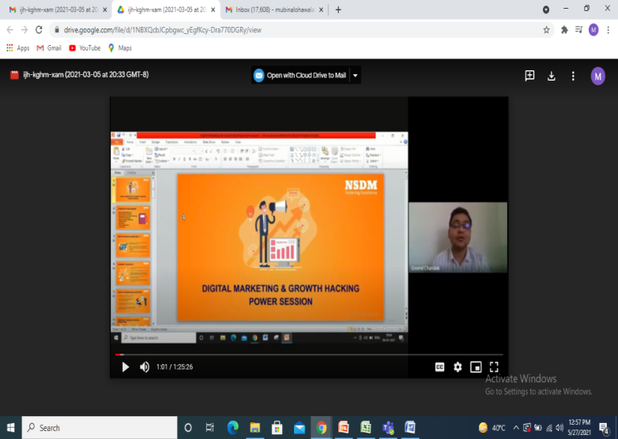

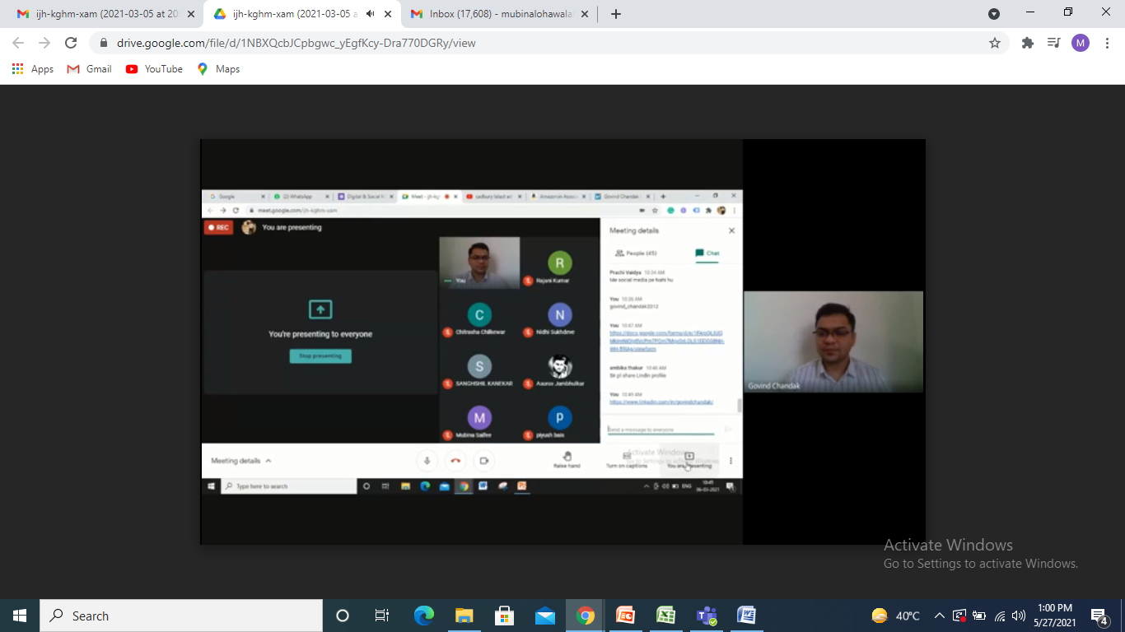

A Webinar on
Secret to Happiness and Success
20 March, 2021
Green Heaven Institute of Management and Research hosted an online guest lecture on life skills titled ‘Secret to Happiness and Success’. The key speaker on the occasion was Mr. Nityanand Tiwari, noted corporate trainer and Managing Director—Tvam.
Mr. Nityanand began his session by telling a story of Japanese Zen master. He emphasized the importance of controling mind and staying focussed on the target. Mr. Tiwari also underlined
the vitality of builidng relationships in life. The guest speaker appealed the students to turn inwards for real happiness in life. He articulated the significance of living a addiction-free life.
The online lecture was attended by large number of students. Dr. Rajani Kumar introduced the guest speaker. Prof. Sameer Padole moderated the session under directions from Dr. Anil harma, Director of GHIMR.
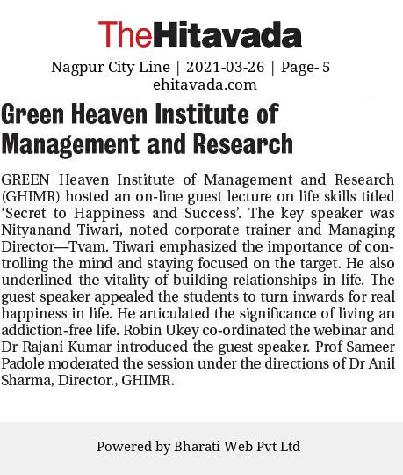
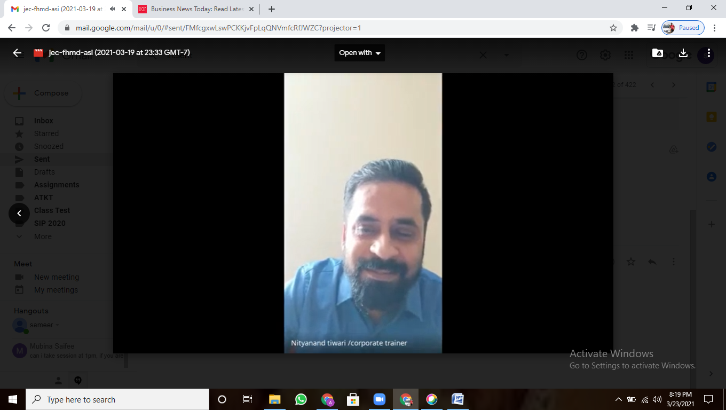

Subject Enrichment by Dr. Ashish Linge
May 2, 2021
The college organized a 3-day subject enrichment workshop for the first semester students from April 29 to May 1. The enrichment was conducted for Business
Statistics and Analytics for Decision Making. The area of enrichment was the fourth module of RTM Nagpur University’s syllabus – Hypothesis testing.
Dr. Linge started with the breakdown of the module into various sub-topics. On April 29, the guest lecturer covered the introduction to hypothesis testing and hypothesis testing procedure. On April 30, Dr. Linge covered topics namely errors in hypothesis testing and power of a statistical test. He also explained the major parametric and non-parametric tests such as students’ T-test, F-test and Chi-square test by solving the practical problems on MS-Excel. On May 1, the guest speaker covered analysis of variance (ANNOVA) and prepared the the students by revision through various multiple choice questions. A large number of students attended the subject enrichment program moderated by Prof. Sameer Padole

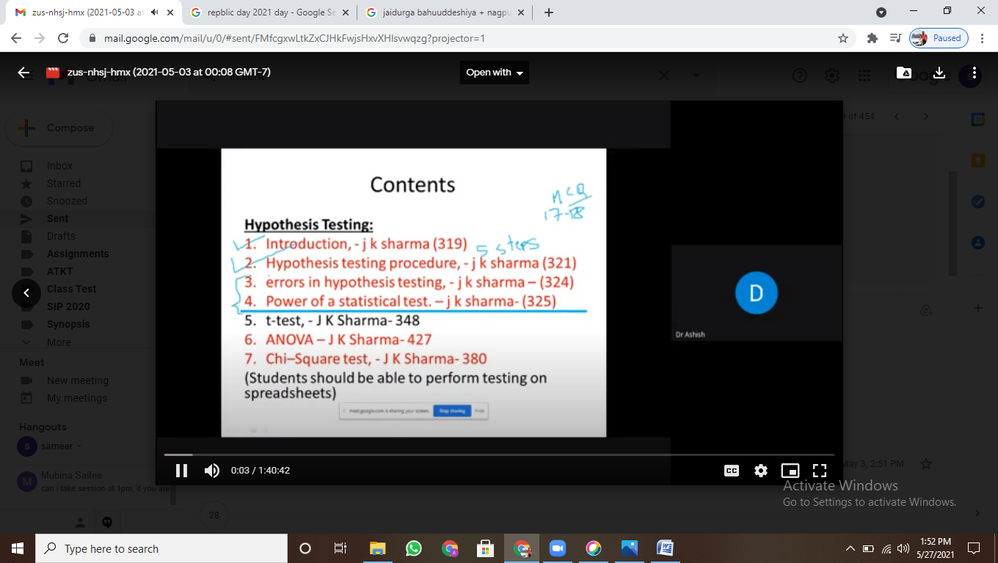

Awards and Recognition

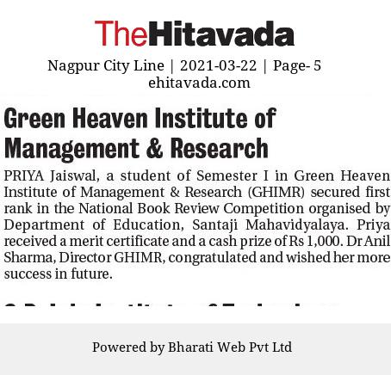

Co-Curricular activities

Independence Day
15th August 2020

74th Independence Day was celebrated at Green Heaven Institute of Management and Research, Nagpur with the high spirits of Patriotism. The Program started with the flag hoisting, which was done at the hands of Chief Guest Mrs. Smt. Narmada Devi Sharmaji, Founder member of Jai Durga Bahu-uddeshiya Jankalyan Sanstha(JBJS)., Also present were Mrs. Asha Sharma, from Management and Dr. Anil Sharma, Director, GHIMR. On this occasion, tree plantation was also done by the hands of Chief Guest and other guests of the occasion, Faculty Members and students in GHIMR campus. Because of the ongoing lockdown, the program was attended only staff of the college. On this occasion the staff was addressed by the chief guest Smt. Narmada Devi Sharma, explaining the importance of this day in today’s scenario. The program was co-ordinated by Dr. Pramod Thaur with the help of other Faculty members and staff. Dr. Anil Sharma, appreciated the efforts of Team GHIMR.

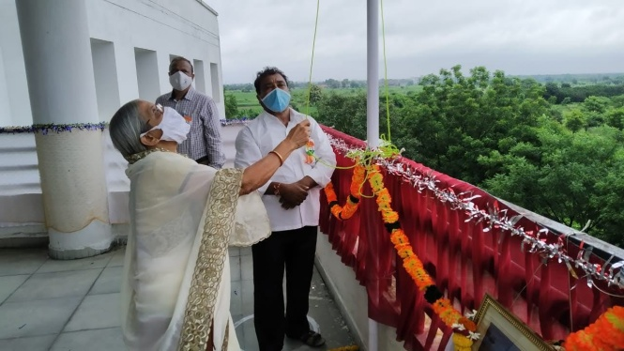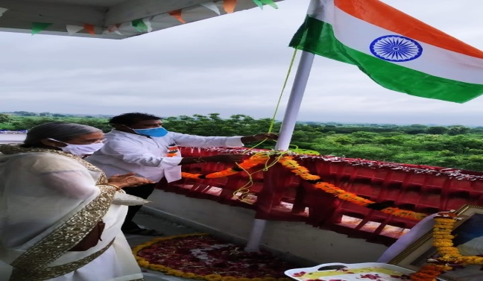

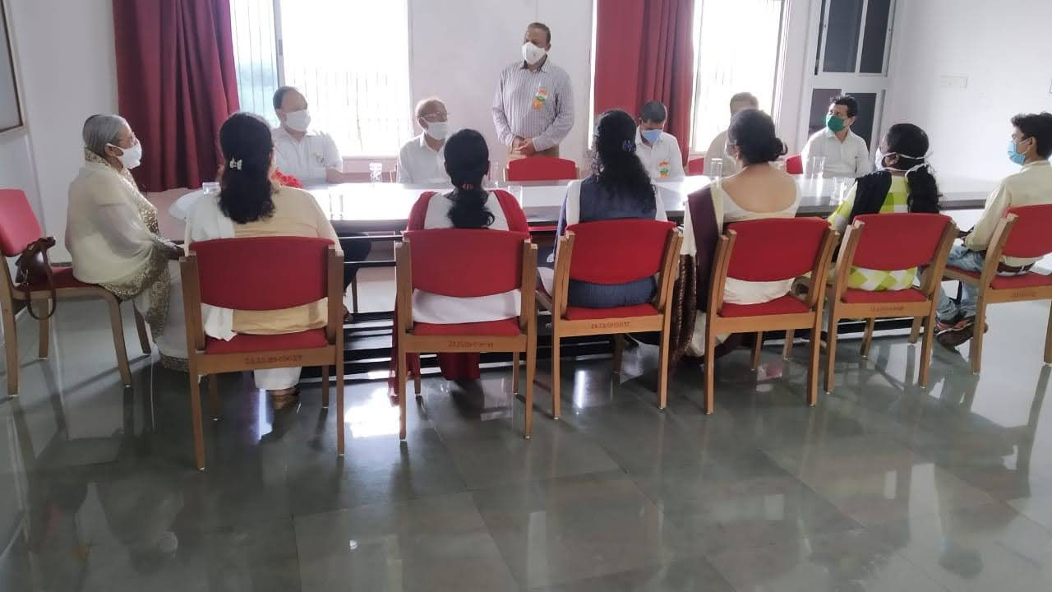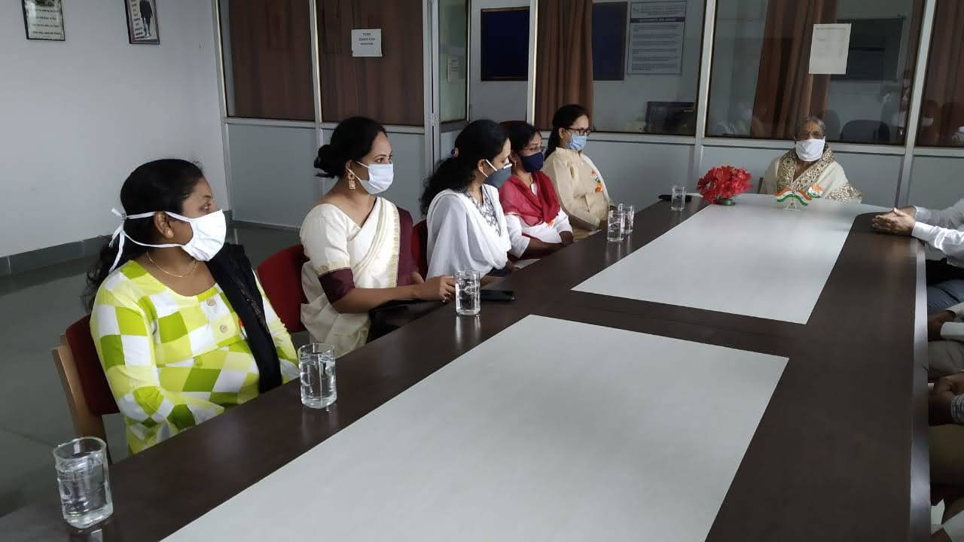
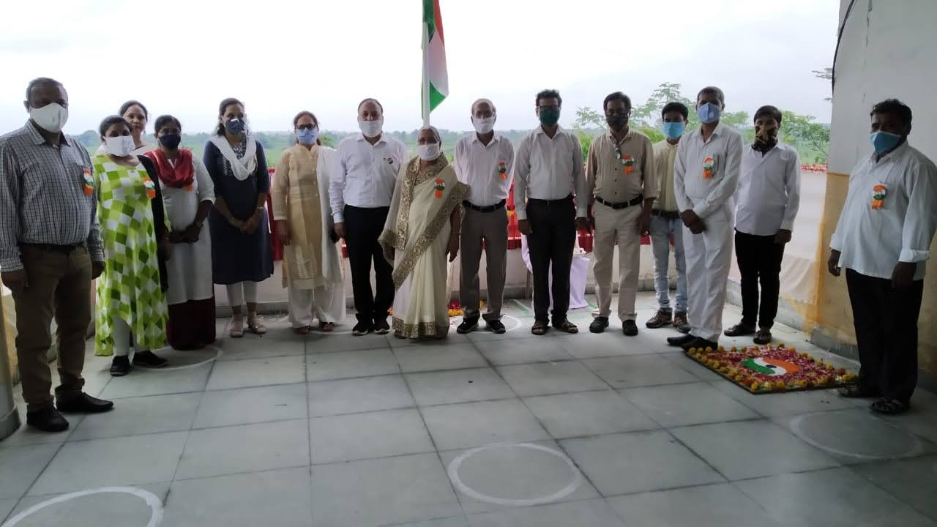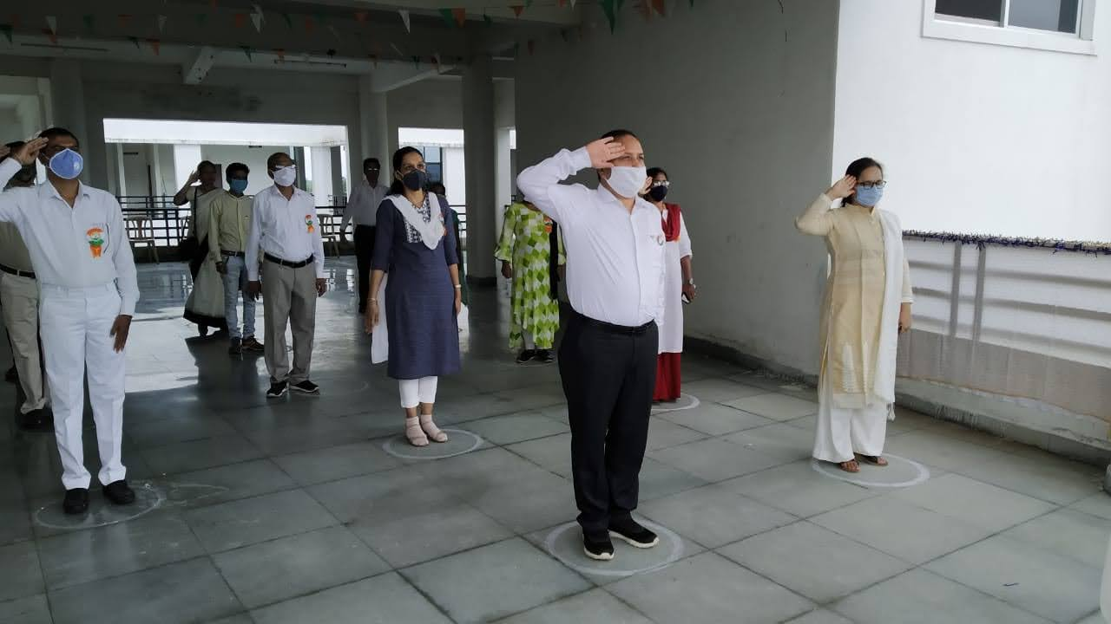

Republic Day 2021

The college celebrated 72nd Republic day on Tuesday, January 26, 2021 on its campus. The program was conducted keeping in mind the pandemic Covid-19 and following all the Covid protocol. Shri. Dhawalasingh Mohite, a noted entrepreneur and trustee of Jai Durga Bahu-Uddeshiya Shikshan Sanstha was the chief guest on the occasion. The flag hoisting ceremony took place at 9:00AM at the hands of the chief guest. The chief guest appealed to the students to take the nation ahead by focusing on agriculture and agro-processing businesses. The program was attended by teaching, non-teaching staff and a large number of students. Prof. Sameer Padole conducted the proceedings of the program and Dr. Mubina Saifee proposed a vote of thanks. Director Dr. Anil Sharma along with Shrimati Mataji and Shri. Chimalwar were prominently present on the occasion.

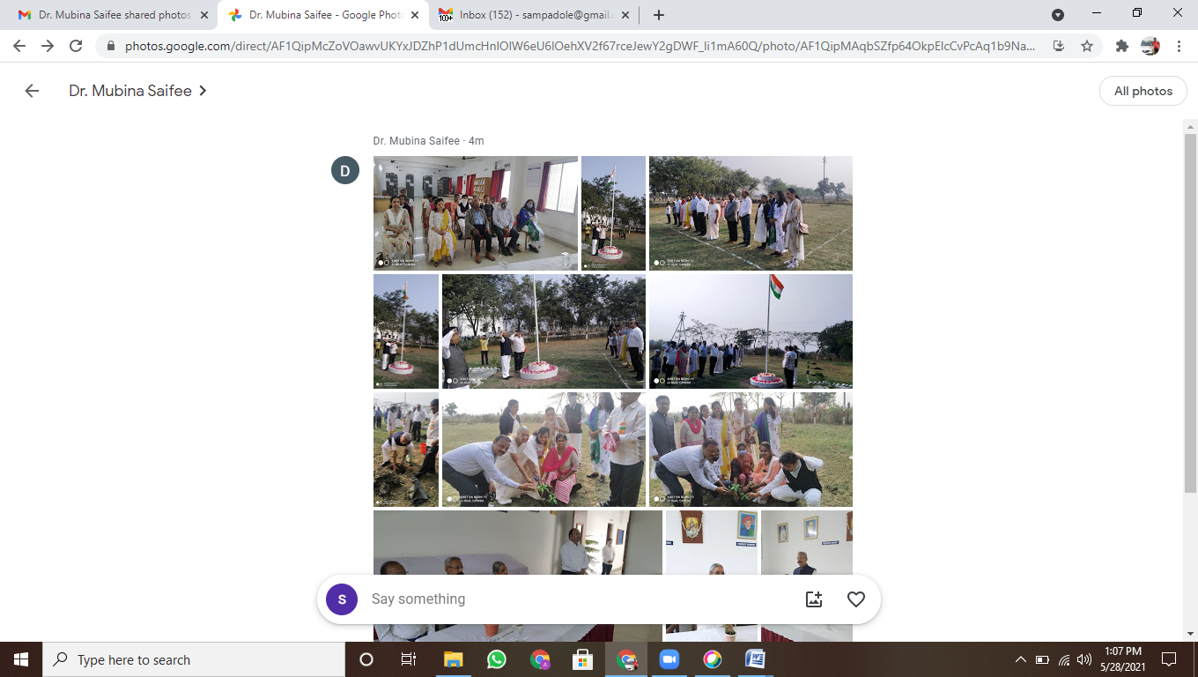

NSS Cell activities

Mask Making and its distribution by NSS Volunteers
20th-27th June 2020

In the wake of Covid-19 spread across the world wearing mask has become a new normal. Wearing mask is compulsory by all the state governments and municipal corporations in cities. Therefore there was a need to educate the people of the country to continue wear mask until the Corona virus disappears. So the NSS Volunteers of Green Heaven Institute of Management and Research was motivated and trained to make the masks at their home and distribute them to their neighborhoods. Students therefore made the mask made from the cloths and things available at their home and distributed them to the people in need which were in their nearby places.

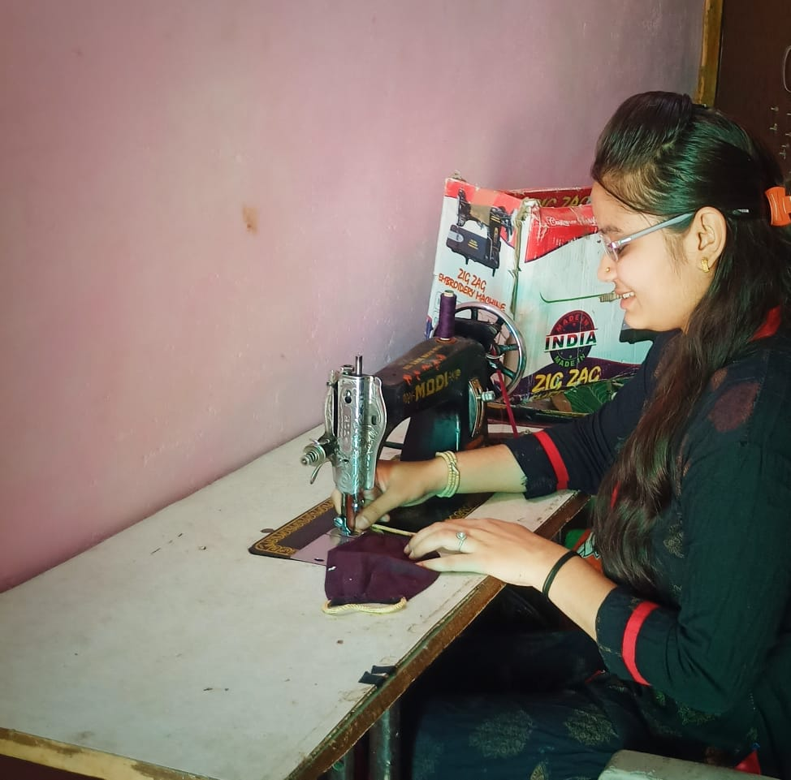

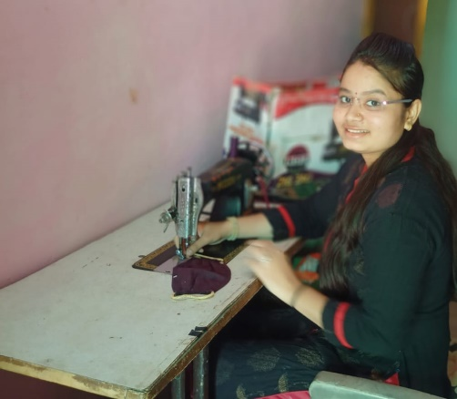

Tree plantation at ghimr campus
15th August 20

A tree plantation drive was held in the college premises on 15th August 20. The duel objectives of this drive were to enhance the tree cover on the campus and to sensitize the students towards importance of trees.
In this program, the staff was made to plant a tree each at the designated place. The Trees were planted by the chief guest of the occasion, Smt. Narmada Devi Sharma, and Director of the Institute Dr. Anil Sharma, in the first place and then all the staff were made to plant the trees. This activity of planting trees has become a tradition for GHIMR students and staff. The students take the responsibility of nurturing their tree. This also creates among the a sense of belonging to their alma mater, But due to lockdown students this year could not come for this tree plantation drive this year.
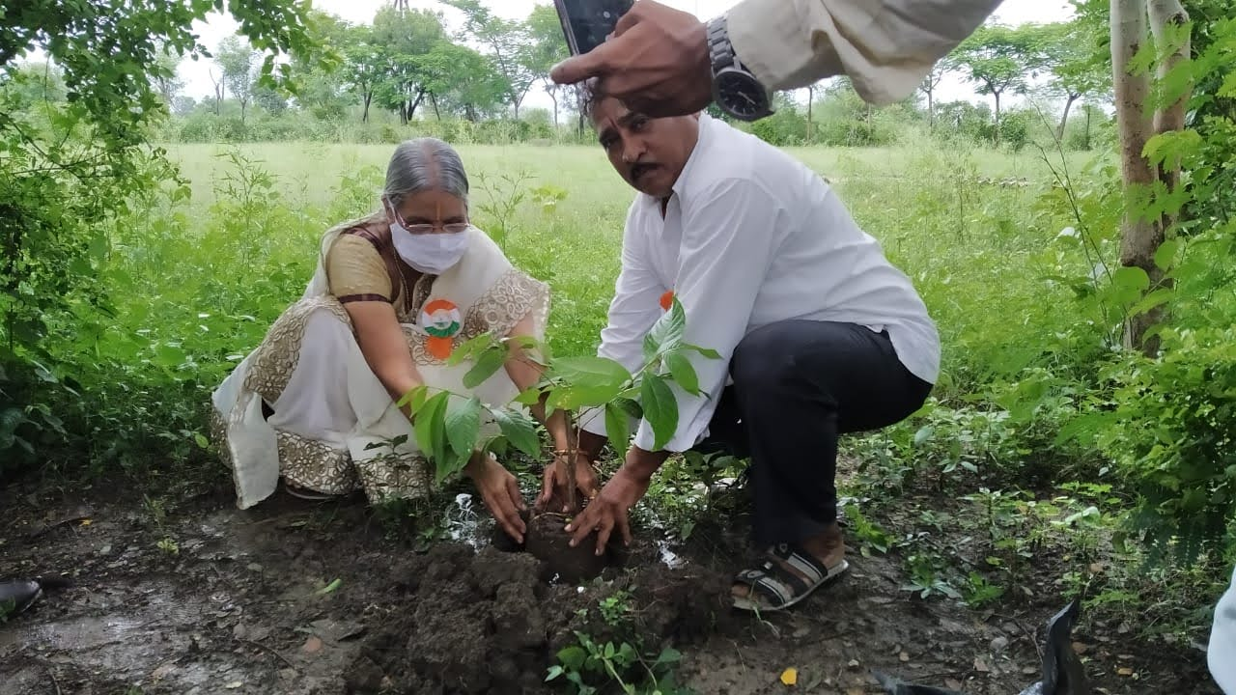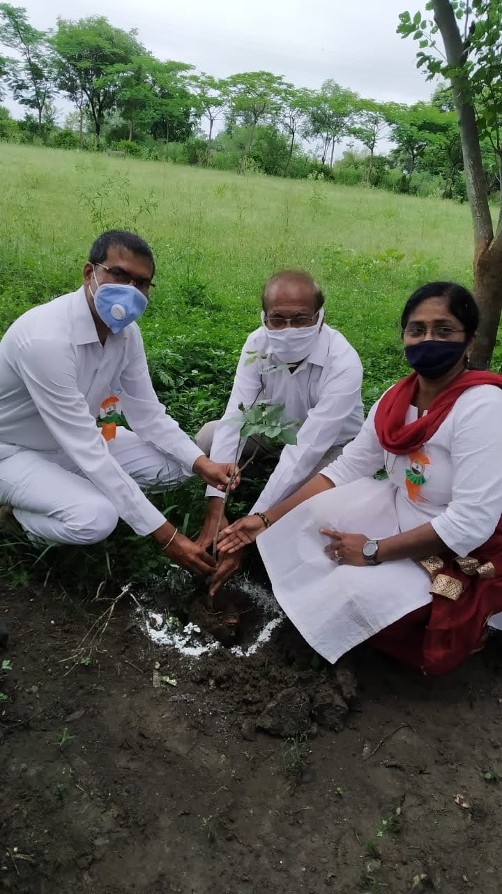

Industry Institute Activities
WEBINAR ON KICKSTARTING ONLINE SIP
25/06/2020

Green Heaven Institute of Management and Research, Nagpur organized a webinar on “Kickstarting Online Summer Internship Projects (SIP)” recently for second semester management students. The key speaker for the webinar was Mr. Vinay Jain, Director, Imperial India Consultants Pvt Ltd.
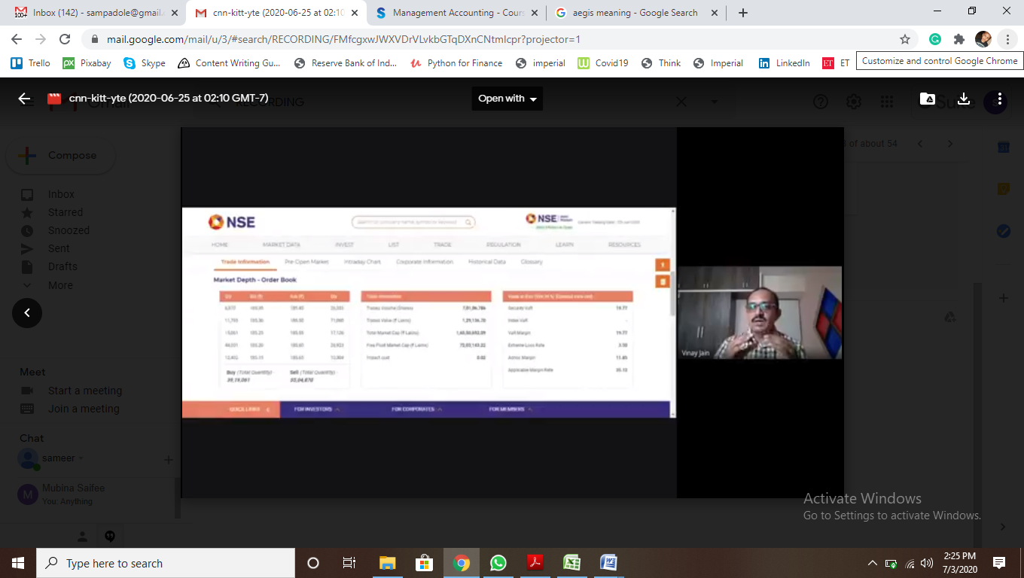
In the webinar, Mr. Jain touched various aspects of how to proceed with the online SIPs in the area of finance, human resource and marketing. He made aware the various online projects and other opportunities available for the students. He also guided the students on how to search and take up short duration projects in the stock market. Mr. Jain demonstrated the students how to make searches and extract data on websites of Indian stock exchanges. The webinar was moderated by Prof. Sameer Padole under the supervision of Dr. Rajani Kumar, Academic Coordinator of the college. Dr. Anil Sharma, Director of GHIMR appreciated the efforts by faculty members.

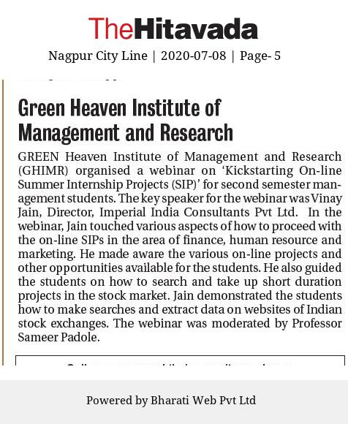
A Webinar on Self Employment Opportunities and Government’s Self Employment Schemes and Subsidiesth
14th July 2020
Green Heaven Institute of Management and Research, Nagpur supported by Maharashtra Centre for Entrepreneurship Development (MCED), MIDC Hingna Center recently organized a webinar on Self Employment Opportunities and Government’s Self Employment Schemes and Subsidies. The key speaker for the webinar was Mr. Shrikant Kulkarni, Project Officer, MCED, Hingna, Nagpur. The college has signed a Memorandum of Understanding (MOU) with MCED for furthering the cause of entrepreneurship among management students. The primary objective of the webinar was to develop entrepreneurship spirit among the management students and to apprise them about the various self-employment opportunities available in today’s era.

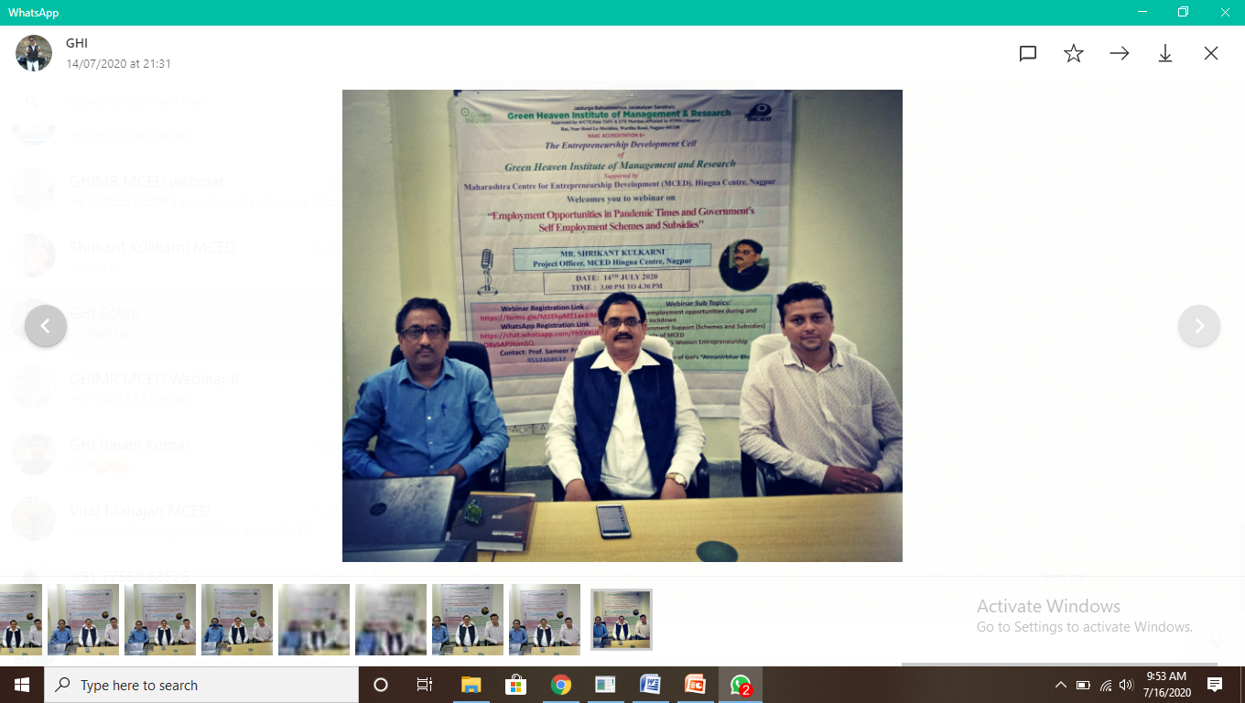
The sub topics of the seminar were Self-employment opportunities during and post lockdown, Government Support (Schemes and subsidies) and role of MCED, Government’s women entrepreneurship policies and the major highlights of Government of India’s Atmanirbhar Bharat Abhiyaan. Mr. Kulkarni spoke at length and explained in detail about how to set up micro, small and medium enterprises (MSME) and state government’s schemes and subsidies and the related training support provided by MCED. He appealed the student community to convert the opportunities offered by COVID-19 lockdown into setting up their own business.
He elaborated in detail on the Chief Ministers’ Employment Generation Program (PMEGP). Under the scheme is available to any individual in the age group 18 to 45. Upper age relaxation of 5 years is offered to persons belonging to SC/ST community, women, ex-servicemen and differently able persons. The educational qualification under the program is 7th pass for project cost ranging between Rs. 10 lacs to Rs. 25 lacs. The same is 10th pass for project cost ranging between Rs. 25 lacs to Rs. 50 lacs. The maximum loan limit for manufacturing project has been set at Rs. 50 lacs while for service project the same is Rs. 10 lacs. Under the PMEGP, the owner’s equity is capped at 10% of the project cost.
The women entrepreneurship Special Policy 2017 aims for making 20% women entrepreneurs in society. Mr. Kulkarni categorically told that women are preferred in government’s loan cases. For marketing support, the state government provides funding for stalls, and reimburses women entrepreneurs’ to and fro charges for participation in foreign countries exhibitions. In

Government scheme, women get more subsidy, electricity exemption per unit. He further stated that separate training programs are sponsored for women by NABARD, DST & SIDBI.
He ended his speech by briefing on the various incentive programs announced under Atmanirbhar Bharat Abhiyaan. He explained how the revision of MSME definition has brought more entrepreneurship activities and businesses in its ambit and facilitated the ease of doing business. Prof. Sameer Padole welcomed the guest speaker and Prof. Robin Ukey proposed a vote of thanks. Dr. Anil Sharma, Director and Rajani Kumar, Academic Coordinator appreciated the staff efforts for organizing the event.
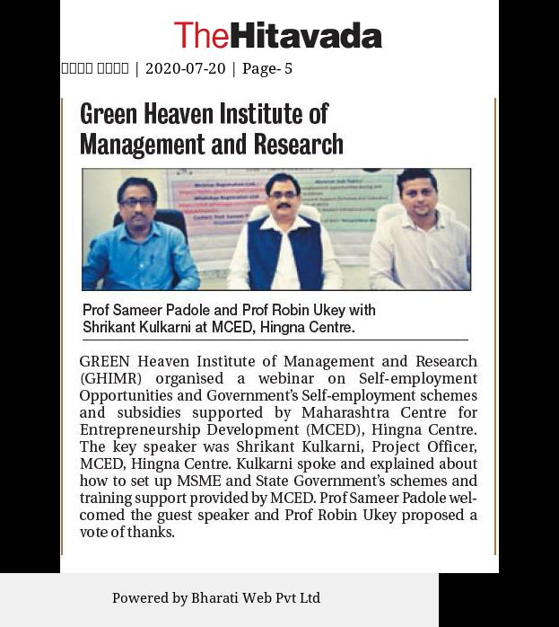
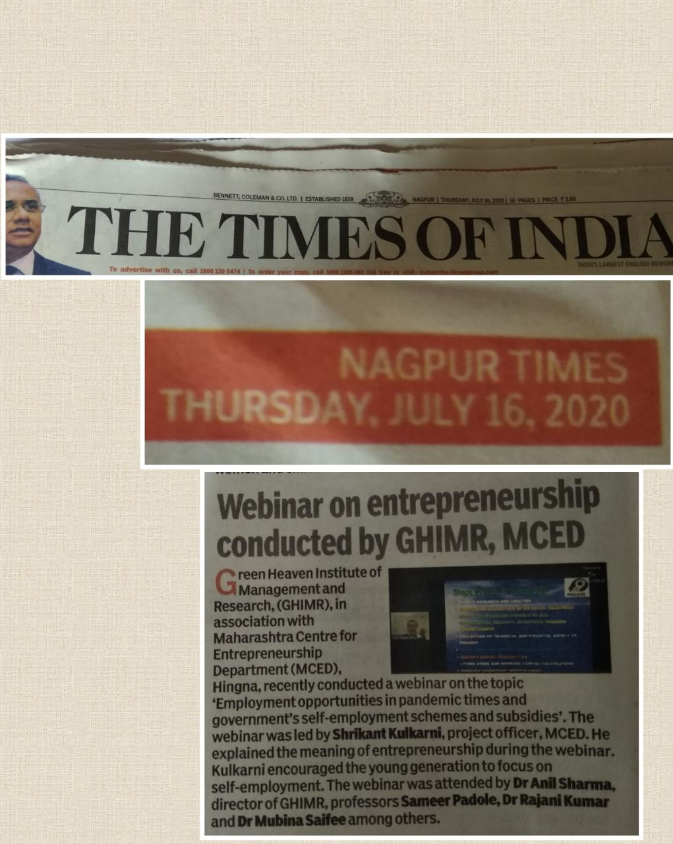

Green Heaven Institute of Management and Research, Nagpur
Workshop on Rural Entrepreneurship Development
30.11.2020

The Rural Entrepreneurship Development Cell of Green Heaven Institute of Management and Research, under Mahatma Gandhi National Council of Rural Education, Department of Higher Education, Ministry of Education, Government of India conducted a One Day Workshop on “Rural Entrepreneurship Development”. The Resource Person,Dr. Mahesh Chopde, Assistant Professor, Jhulelal Institute of Technology and Faculty Coordinator for Mahatma Gandhi National Council of Rural Education informed the students about the objectives of Rural Entrepreneurship Development Cell and the role to be played by the students.
The live examples and case studies cited enabled students to understand the scope and opportunities in rural entrepreneurship. The session was quite interactive and brainstorming which forced students to think out of box and come up with innovative ideas to boost the economic activities of Rural masses and help them in the their livelihood. Director, Dr. Anil Sharma appreciated this initiative and encouraged students to come up with good, innovative business ideas. He also promised that the College would provide necessary inputs and guidance to make the idea effective. The Workshop was coordinated by Dr. Rajani Kumar, Academic Coordinator and Prof. Sameer Padole, Student Development Officer,Rural Entrepreneurship Development Cell.

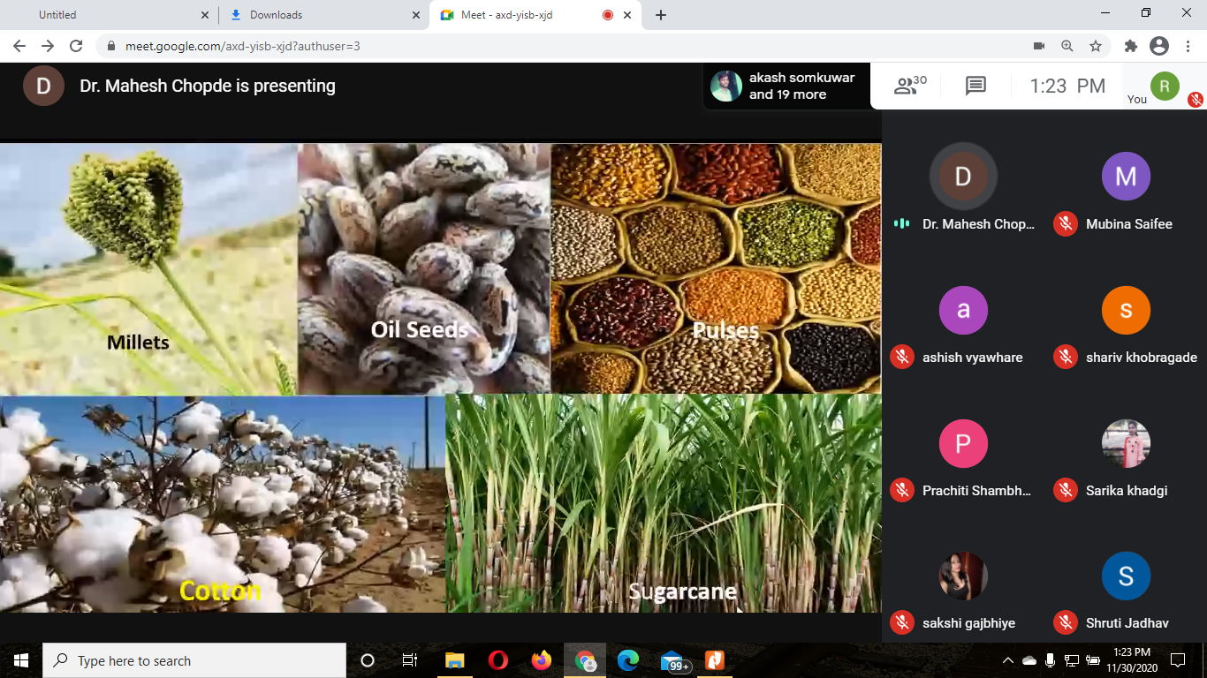

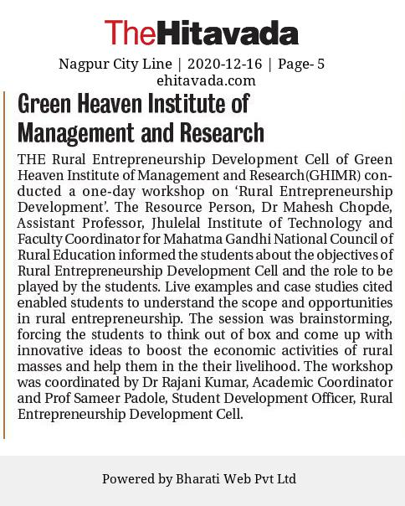

Training and Placement activities

GHIMR Training & Placement Cell
Trainings and Summer Internship Program (SIP) Report
The main objective of the Training & Placement cell (T&P cell) is to provide exposure to students, train them and make them industry-ready. The T&P cell strives to achieve the objective of facilitating corporate exposure to students. In view of the Covid-19 pandemic and as per specific guidelines from AICTE, most of the Summer Internship Projects (SIP) for 2020-21 was undertaken in online mode.
The T&P cell regularly engages in industry institute interactions and lot of other activities focused on employability building, professional networking, improving students’ interpersonal skills and exploring employment opportunities for the students. These activities include:
- Industry Specific Training (HR analytics, Marketing analytics and Financial analytics)
- Summer Internship Projects
- Local and Outbound Industrial Visits
- Personality Development Programs
- Industry Focused Minor Research Projects
- Interview Preparation Sessions in the form of Mock Group Discussion and Personal Interview Sessions
- Liaison and Inviting Companies for Interviews
- Assisting Employers in Various Layers of Candidate Selection
- Final Selection and Placement of Students

Training Programs
As a precursor to interview at Equitas Small Finance Bank Ltd, the T&P cell organized a one-hour online training program for its final semester students on January 28, 2021. The training program on Banking, Financial Services and Insurance sector (BFSI) was imparted by Prof. Sameer Padole. The training program was organized to train students on the BFSI domain before appearing for interview at Equitas Small Finance Bank Ltd on January 29 for the post of Relationship Manager (RM-CASA). Seven students who were shortlisted for the interview attended the online training program.

Summer Internship Projects (SIP) Placements
GHIMR successfully placed all the second semester students who registered for the Summer Internship Projects (SIP) with T&P cell. Due to pandemic Covid-19, most of the SIP was completed in online mode. The students were placed in SIPs of their choice based on their intended specialization in the third semester. The functional areas of SIP were Finance, Human Resource, Marketing, Information Technology and Operations. Most students preferred finance domain as their choice of summer internship project. The operations companies mostly covered healthcare services firms.
SIP 2020-21 at a Glance
No. of Eligible Students | 65
No. of Students Who Completed Their SIP | 65
No. of Students Asked to Repeat SIP due to Unsatisfactory Performance | 0
Percentage of Students Successfully Completed SIP in 1st Attempt | 100%
No. of Companies Participated in SIP | 23
No. of Sectors Covered in SIP | 8
No. of Functional Areas Covered in SIP | 5
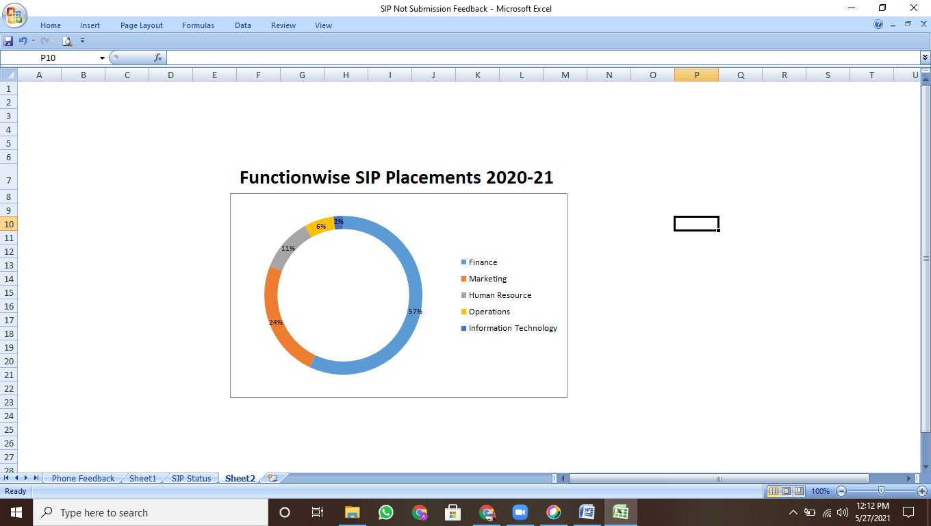
The summer internship project duration ranged between 45 to 60 days. All the students completed their SIP in June to August 2020. The major companies where students were placed for their SIP include:
- Indusind Bank
- Vodafone Idea
- Imperial India Consultants Pvt Ltd
- Ascent Business Solutions IT Park
- Diagnoplus Health Services Pvt Ltd
- Shri Jalaram Fragrance Pvt Ltd
- Spandan Digital
- Aerographic Papers Pvt Ltd
- Credit Avenue
- CIEL HR Services Pvt Ltd
- GREIPL Pvt Ltd.

Campus Placements 2020-21
